# NBC Sets Premiere Date for Christopher Meloni-Led LAW & ORDER Spinoff ORGANIZED CRIME

February 4, 2021 by [Marisa Roffman](https://www.givememyremote.com/remote/author/marisa/)

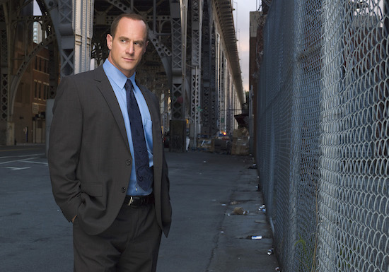

***LAW & ORDER: SPECIAL VICTIMS UNIT***  
***Pictured: Christopher Meloni as Det. Elliot Stabler***

NBC has set a Thursday, April 1 premiere date for its new midseason drama, LAW & ORDER: ORGANIZED CRIME.

ORGANIZED CRIME, which stars [Christopher Meloni reprising his LAW & ORDER: SPECIAL VICTIMS UNIT character Elliot Stabler](https://www.givememyremote.com/remote/2020/12/08/svu-stabler-return-of-the-prodigal-son/), will air Thursdays at 10/9c, after SVU. (Meloni will also [make his franchise return that night on SVU at 9/8c](https://www.givememyremote.com/remote/2021/01/15/benson-stabler-reunion-svu-2021/), for what NBC is dubbing “a must-watch” 2-hour event.)

In the series, Stabler “returns to the NYPD to battle organized crime after a devastating personal loss. Stabler will aim to rebuild his life as part of a new elite task force that is taking apart the city’s most powerful criminal syndicates one by one.” The series also stars [Dylan McDermott](https://www.givememyremote.com/remote/2021/01/27/law-order-organized-crime-dylan-mcdermott-joins-new-nbc-drama/) and [Tamara Taylor](https://www.givememyremote.com/remote/2021/02/02/law-order-organized-crime-adds-bones-tamara-taylor/).

Ilene Chaiken is running the series, [after stepping in as showrunner in December](https://www.givememyremote.com/remote/2020/12/09/law-and-order-organized-crime-boss-ilene-chaiken/).

NBC also released the first photo of Meloni as Stabler in the ORGANIZED CRIME premiere, seemingly called “What Happens in Puglia”…

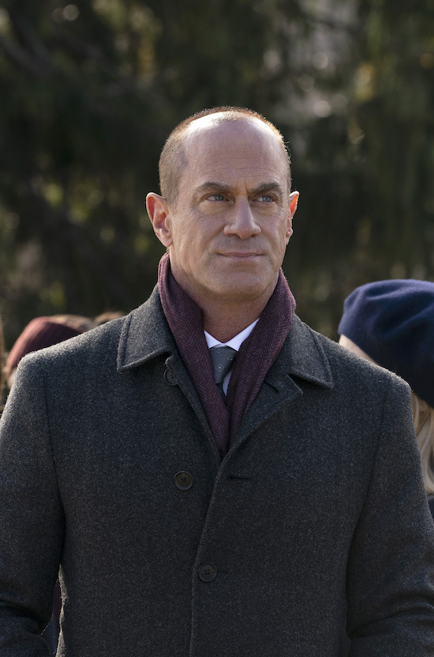

***LAW & ORDER: ORGANIZED CRIME — “What Happens in Puglia” Episode 101 — Pictured: Christopher Meloni as Detective Elliot Stabler — (Photo by: Virginia Sherwood/NBC)***

**RELATED:**

* [Christopher Meloni Shares On-Set SVU Reunion Photo with Mariska Hargitay](https://www.givememyremote.com/remote/2021/01/15/benson-stabler-reunion-svu-2021/)
* [LAW & ORDER: ORGANIZED CRIME Sets Ilene Chaiken as Showrunner](https://www.givememyremote.com/remote/2020/12/09/law-and-order-organized-crime-boss-ilene-chaiken/)
* [Christopher Meloni Shares First Photos of Elliot Stabler’s SVU Return](https://www.givememyremote.com/remote/2020/12/08/svu-stabler-return-of-the-prodigal-son/)
* [SVU Boss Shares First Rehearsal Photo From ORGANIZED CRIME Crossover](https://www.givememyremote.com/remote/2020/12/02/svu-photo-stabler-benson-reunion-2021/)
* [Christopher Meloni Shares First Photos of Elliot Stabler’s SVU Return](https://www.givememyremote.com/remote/2020/12/08/svu-stabler-return-of-the-prodigal-son/)
* [LAW & ORDER: ORGANIZED CRIME: 6 Burning Questions about the New SVU Spinoff](https://www.givememyremote.com/remote/2020/07/30/law-and-order-organized-crime-questions-season-1/) pixel
* [Mariska Hargitay and Christopher Meloni Reunite Ahead of LAW & ORDER Collaboration](https://www.givememyremote.com/remote/2020/07/19/mariska-hargitay-chris-meloni-reunion-2020-svu-organized-crime/)
* [Christopher Meloni Teases LAW & ORDER: ORGANIZED CRIME and the Benson-Stabler Reunion](https://www.givememyremote.com/remote/2020/07/07/law-and-order-organized-crime-chris-meloni-benson-stabler-reunion/)
* [It’s Official: NBC Orders SVU Spinoff Starring Christopher Meloni](https://www.givememyremote.com/remote/2020/06/16/its-official-nbc-orders-svu-spinoff-starring-christopher-meloni/)
* [LAW & ORDER: SPECIAL VICTIMS UNIT Boss: The Plan is for Stabler to be in the Season 22 Premiere](https://www.givememyremote.com/remote/2020/05/01/elliot-stabler-return-svu-22-premiere-spoilers-squadroom-interview/)
* [Mariska Hargitay Reacts to Chris Meloni’s New Elliot Stabler Series: ‘Welcome Home’](https://www.givememyremote.com/remote/2020/04/02/mariska-hargitay-chris-meloni-new-stabler-series-reaction/)

*Follow* [*@GiveMeMyRemote*](http://twitter.com/givememyremote) *and* [*@marisaroffman*](http://www.twitter.com/marisaroffman) *on Twitter for the latest TV news. Connect with other TV fans on* [*GIVE ME MY REMOTE’s official Facebook page*](http://www.facebook.com/GiveMeMyRemote)*.*

*And be the first to see our exclusive videos by subscribing to our* [*YouTube channel*](https://www.youtube.com/user/GiveMeMyRemoteTV)*.*

*As an Amazon Associate we earn from qualifying purchases made through links/ads placed on the site.*

### **RELATED POSTS**

* [LAW & ORDER: ORGANIZED CRIME Teaser: Stabler Addresses His Decade-Long Absence](https://www.givememyremote.com/remote/2021/02/18/law-and-order-organized-crime-teaser/)
* [LAW & ORDER: ORGANIZED CRIME Temporarily Shuts Production Down Due to COVID-19](https://www.givememyremote.com/remote/2021/02/06/law-and-order-organized-crime-covid-19-shut-down/)
* [Watch Benson and Stabler Reunite in New LAW & ORDER: SPECIAL VICTIMS UNIT-ORGANIZED CRIME Crossover Promo](https://www.givememyremote.com/remote/2021/02/25/svu-stabler-benson-reunion-video-2021-organized-crime/)
* [Christopher Meloni Shares On-Set SVU Reunion Photo with Mariska Hargitay](https://www.givememyremote.com/remote/2021/01/15/benson-stabler-reunion-svu-2021/)
* [Christopher Meloni Shares First Photos of Elliot Stabler’s SVU Return](https://www.givememyremote.com/remote/2020/12/08/svu-stabler-return-of-the-prodigal-son/)